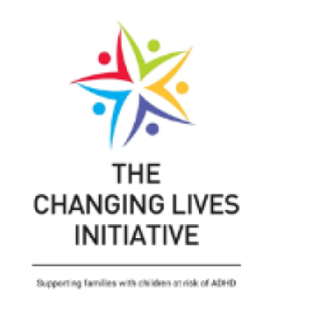

Registration Form for Parent Information & Awareness workshop sessions (via Zoom).
N.B. Information marked * is required.

- Name:*

- Email address:*

- Phone contact number (optional, but will help us to discuss workshop options with you quickly if needed):

- Are you registering for this workshop as (please tick or highlight in bold):*
- A parent / carer / family member
- A professional

- Which Health Trust area do you live in (please tick or highlight in bold)?*
- Belfast
- South Eastern
- Western
- Southern
- Northern
- Other area outside Northern Ireland (please specify) _____________________

- What age is the child you are registering for this workshop because of?*
______________ years old

- Does this child have an ADHD diagnosis?* YES / NO

- Does this child have an ASD diagnosis?* YES / NO

- Which of these times would suit you best to take part in an online workshop? (please underline or highlight in bold)?
Morning / Afternoon / Evening

- We need to send you written materials before the workshop. If you are not able to print these off, and would prefer us to post them to you, please provide your full address and postcode:
_____________________________________________________________________

_____________________________________________________________________

- Would you like to receive the Changing Lives Initiative e-zine? YES / NO

__________________________________________________________________________________
The Changing Lives Initiative takes data protection seriously. Please read our Privacy Policy for more information on how we use your data and what your rights are.
When you return this registration form we will check that this information and awareness workshop is suitable for you, and that a workshop is available at a time that suits you.
We will then send you log-in details and a password so you can join in.
Thank you.
Please complete and return this registration to: changinglives@newcolin.com

The Changing Lives Initiative is funded by the EU through the INTERREG VA Programme:

