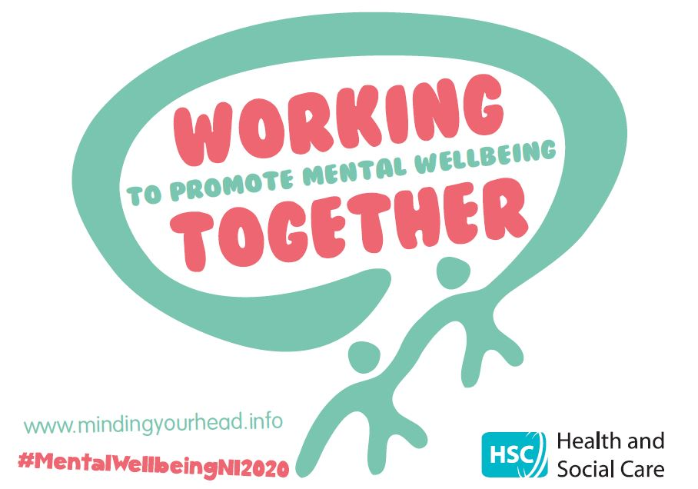

Mental Wellbeing campaign 2020

Messaging calendar
Week 3: 21 September 2020
TAKE NOTICE

#MENTALWELLBEINGNI2020

Date | Message | Social media assets
Monday 14 September | Facebook and Instagram  This week we are focusing on the need to TAKE NOTICE as one the Take 5 Steps to Wellbeing.  Melanie Breslin from The Baking Mind shares with us the need to take notice of our thoughts and feelings and the world around us to promote positive mental and emotional wellbeing.  For more information on the campaign and how you can TAKE NOTICE visit: www.mindingyourhead.info  #MentalWellbeingNI2020  Twitter  Melanie Breslin from The Baking Mind shares with us the need to take notice of our thoughts and feelings to promote positive mental and emotional wellbeing. Visit: www.mindingyourhead.info #MentalWellbeingNI2020 | Facebook and Instagram  Vimeo link:  https://vimeo.com/459030843  PASSWORD: TakeNotice  WeTransfer link:  https://wetransfer.com/downloads/ab05a302b75e43980f7c716c26b74b5d20200917154309/bca6a024f53102ca3400170fec67a63420200917154320/a4830c  Twitter  Vimeo link:  https://vimeo.com/459024422  PASSWORD: TakeNotice  WeTransfer link:  https://wetransfer.com/downloads/ab05a302b75e43980f7c716c26b74b5d20200917154309/bca6a024f53102ca3400170fec67a63420200917154320/a4830c
Wednesday 16 September | Facebook and Instagram  This week we are focusing on the need to TAKE NOTICE. Being aware in the present moment – of your own thoughts and feelings and the world around – can help us to feel calm and relaxed and to think more positively.  Taking notice and being consciously aware of your body sensations, thoughts, feelings and emotions can help us understand our feelings and recognise negative emotions, such as feelings of stress.  Visit https://ni.stresscontrol.org/ to access free online stress control classes to gain skills to help you cope with stress and anxiety.  #MentalWellbeingNI2020  Twitter  Being consciously aware of your thoughts, feelings and emotions can help us to recognise negative emotions and signs of stress. Visit https://ni.stresscontrol.org/ for stress control classes #MentalWellbeingNI2020 | Facebook and Instagram  Vimeo link  https://vimeo.com/459033643  PASSWORD: TakeNotice  WeTransfer link:  https://wetransfer.com/downloads/11296f7796418a2bc0415c54ed283f9420200916124843/83506ecf252117ca2ba6d6f42c861acc20200916124908/b4d206  Twitter  Vimeo link:  https://vimeo.com/459031420  PASSWORD: TakeNotice  WeTransfer link:  https://wetransfer.com/downloads/11296f7796418a2bc0415c54ed283f9420200916124843/83506ecf252117ca2ba6d6f42c861acc20200916124908/b4d206
Additional posts  **nb these can be shared at any time throughout the week | Facebook and Instagram POST 1  This week we are focus on the TAKE NOTICE as one of the 5 Steps to Wellbeing. Take Notice is about taking a little bit of time each day to stop, pause, be still and focus on the present moment. This can help us to connect and understand ourselves and the world and people around us and appreciate things we may normally take for granted.  Visit www.mindingyourhead.info for information on ways you can TAKE NOTICE #MentalWellbeingNI2020  Twitter POST 1  Take Notice is about taking time each day to stop, pause, be still and focus on the present moment. This can help us to connect and understand ourselves and the world around us. Visit www.mindingyourhead.info #MentalWellbeingNI2020

