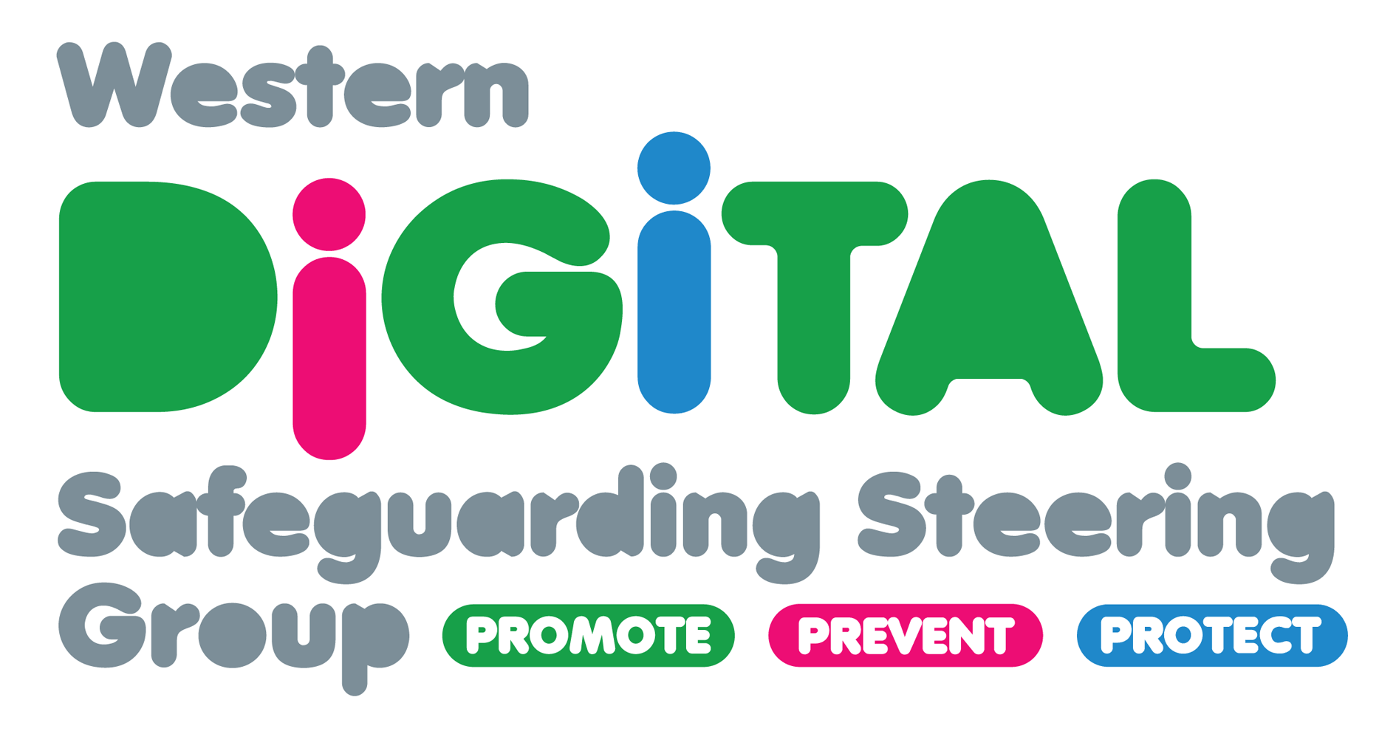
Tuesday 9th February 2021
SAFER INTERNET DAY EVENT INFORMATION
The Western Digital Safeguarding Steering Group is delighted to host online events for Safer Internet Day 2021. If you are confirmed as having secured a place, you will be automatically able to attend either one or all of the events planned for the day. Please keep your diary free between 10am and 3pm and come to one or all the events planned! Exact timings will be confirmed at a later date.
Sessions confirmed so far include:
‘Should I or shouldn’t I look?– Ethical debates about Facebook in safeguarding children’ Facilitated by Dr Tarsem Singh-Cooner
‘The fading grey line between Gaming and Gambling- The Challenges facing Parents and Carers and what we can do’ Facilitated by Paula Gibson, GamCare
The events will be around 1-2 hours each and will include direct teaching, small group activities and action planning for your own workplace setting. We will not overlap sessions so you will be able to attend all events should you wish to do so.

Technical requirements: We will be using Zoom so you will need a device (laptop, PC, tablet or mobile device) to take part. It will be ideal if you have a webcam for the break out room sessions but as a minimum, a microphone to take part verbally will suffice. Most laptops, tablets and mobile devices have built-in webcams and microphones so we would encourage you to download Zoom and practice using this platform on the device you will be using to avoid any difficulties on the day as we are unable to respond to any technical issues. Therefore we strongly encourage you to familiarise yourself with the platform before the day.

Target audience- This event is suitable for all professionals working directly with children and families including social work, education, probation, early years, police, youth services, voluntary and community services etc.

The sessions are not designed for parents, carers, children or young people but are focused on supporting practitioners working with these service user groups.

There are a range of services online for parents/carers requiring support to safeguard their children when using technology as well as supports for children and young people. Please check out ParentZone, the UK Safer Internet Centre, NSPCC and CEOP at the links below -

https://parentzone.org.uk/
https://www.nspcc.org.uk/keeping-children-safe/online-safety/
https://www.saferinternet.org.uk/
https://www.thinkuknow.co.uk/

Places are unavailable to private organisations, companies, fee-based service providers or the general public.

Booking conditions- Your Eventbrite ticket is provisional. You will receive an email closer to the event date to confirm if you have successfully secured a place. Those unable to demonstrate how this event relates to their direct work with children and families will not be offered a place. We strongly recommend you do not use personal email addresses as you will be asked to demonstrate which organisation you work for and how this event relates to your direct work with children, young people, parents and/or carers.

A Zoom link will be emailed to you a couple of days before the online sessions. Please check all your email boxes including your ‘junk’ or ‘spam’ folders. You are not authorised to ‘share’ your link with anyone else- anyone who has not been given a place on the event will be removed from the sessions.

Book your place here- https://www.eventbrite.co.uk/e/western-digital-safeguarding-steering-group-safer-internet-day-events-tickets-131837667011

