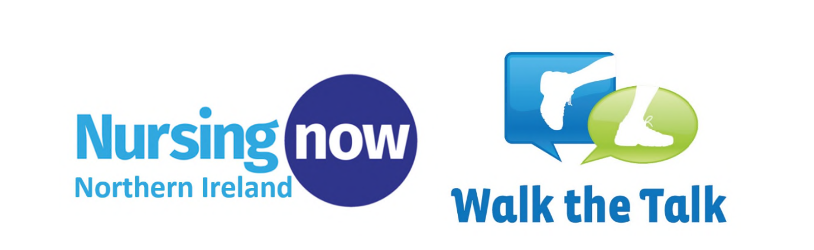

Dear Colleagues,

As part of our celebrations for Nursing Now NI 2021 and to celebrate International Nurses Day and International Midwives Day we are encouraging a 5K Run/Walk/Jog in local areas across Northern Ireland. This will involve Health and Social care staff running, walking or jogging 5K either at their local Parkrun, a Northern Ireland landmark or at a safe location of their choosing.

Participants can then share pictures or videos of their achievements via twitter, using the hashtag #healthforallNI

The aim of this event is to support the Health and Well-being needs of our Health and Social Care Staff, their families and friends by encouraging them to be physically active and mentally well for their own health and that of others.
The 5K run/walk/jog is an opportunity for everyone to run, walk or jog 5K on a route of their choosing and at any time. This event is open to everyone and we would like to encourage participation from all abilities.

This challenge will need to be adapted to follow COVID 19 health recommendations at the time (Coronavirus (COVID-19) regulations guidance: what the restrictions mean for you nidirect) and therefore we are asking participants to consider completing the challenge in the week leading up to and after International Nurses Day which is the Wednesday 12th May or International Midwives Day which is Wednesday 5th May, therefore between the 1st and 16th May 2021.

HOW TO GET INVOLVED:
The Department of Health are encouraging Nursing Staff to complete a 5k in May. This 5k can be undertaken independently or with a small group (adhering to current restrictions and social distancing).
This is an opportunity for everyone to run, walk, and jog 5K on a route of their choosing at any time. These runs are open to everyone and the Department of Health encourage participation from all abilities.

Health and Social care staff who have never run or walked 5K can be encouraged to take part in the couch to 5K programme.
Couch to 5K: week by week – NHS (www.nhs.uk).
This is a running plan for absolute beginners which helps you gradually work up towards running 5K within 8 weeks. It can be downloaded via the NHS app and is supported by podcasts. If participants have any concerns about beginning an exercise regime; please discuss with your GP first.

Why? Nursing Now is a global campaign to improve health by raising the status and profile of nurses. As nurses, midwives and allied health professionals we play a crucial role in health promotion, disease prevention and treatment. Let us lead the way in promoting the benefits of walking and running. It will not only improve our physical and mental health but will give us an opportunity to celebrate our successes and achievement’s throughout this unprecedented year.

WHEN?
Saturday 1st - 16th May 2021

WHERE?
‘Parkruns’ usually take place in your areas across Northern Ireland, however, these are currently not taking place due to COVID-19. We therefore encourage participants to run, jog or walk anywhere providing it is safe to do so.

Nursing Now aims to improve health globally by raising the profile and status of nurses worldwide – influencing policymakers and supporting nurses themselves to lead, learn and build a global movement.
The 3 year campaign (2018 – 2020), which will now end in May 2021 is run in
collaboration with the World Health Organization and the International Council of Nurses, it is focused on five core areas:
1. Ensuring that nurses and midwives have a more prominent voice in health
policy-making
2. Encouraging greater investment in the nursing and midwifery workforce
3. Advocating more nurses and midwives into leadership positions
4. Conducting research that helps determine where nurses and midwives can
have the greatest impact
5. Sharing examples of best nursing practice

We are partnering with WHO’s ‘Walk the Talk: Health for all’ campaign. This aims to
promote the many different benefits of being active, from improving physical health to
contributing to the growth and well-being of local communities.
This campaign is about doing what we say we will when it comes to physical activity.

Let’s not just talk the talk, but get out there and walk.
For any further information please contact:

Debbie.sterritt@health-ni.gov.uk
Calum.grant@health-ni.gov.uk

